Day2 Assignment:

Git- resolve merge conflict: Created two branches from master and edited the same file in both the branches, so while merging back to master, got conflict. resolved using default vi editor and committed the file to master. Please find below the screenshots:

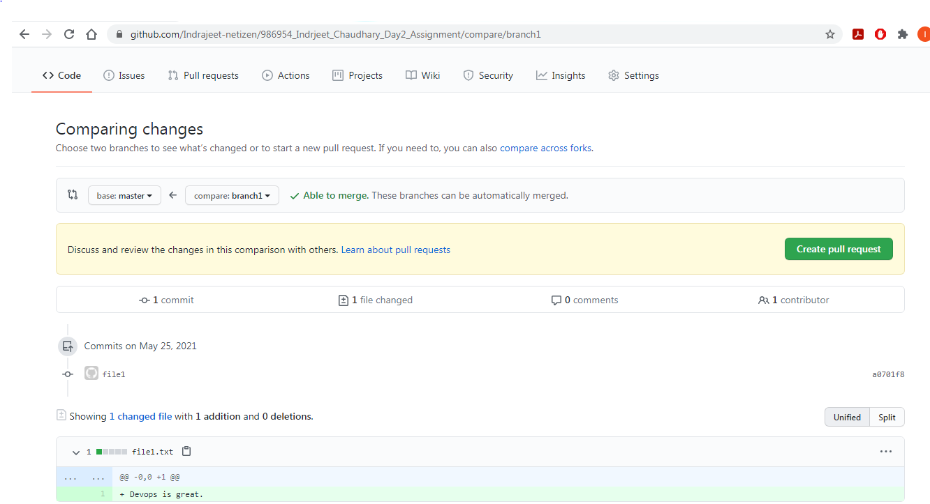

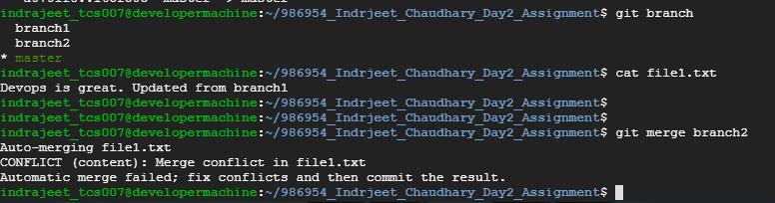

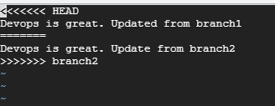

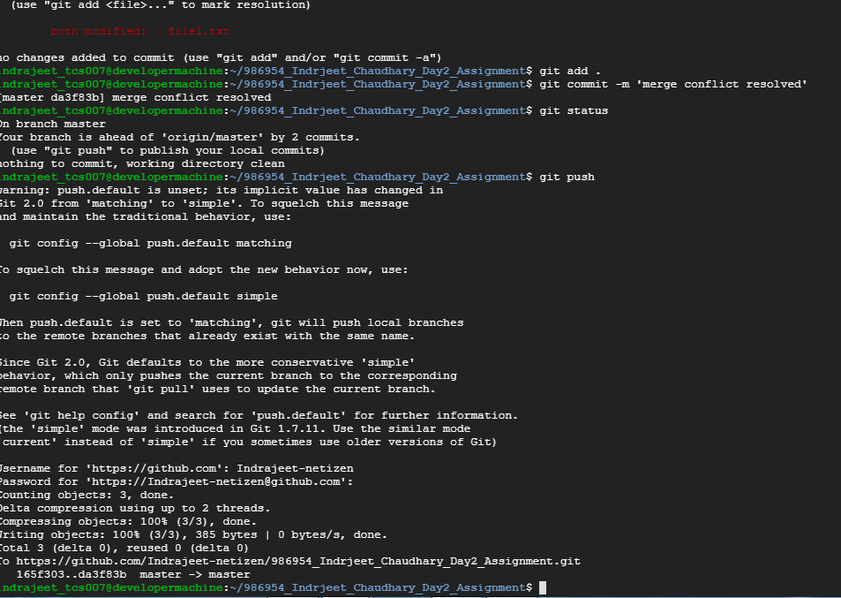

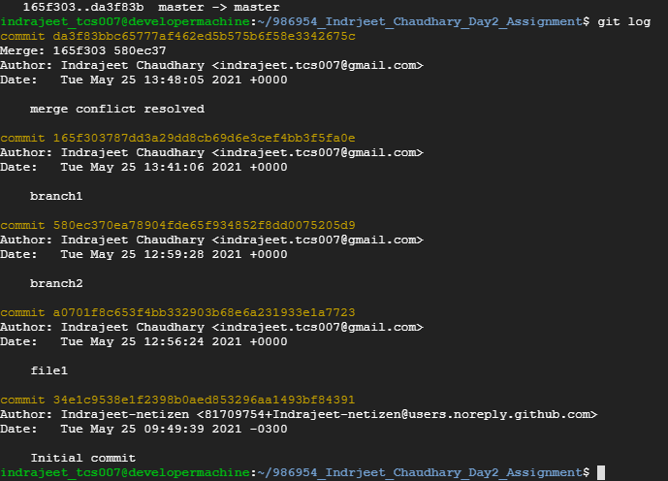

Jenkins: Creating Pipeline:

1. Created a pipeline in jenkins to checkout build and deploy the code from github. After successful build the war file created is deployed to tomcat running on google cloud server. Below is the screenshots:
2. 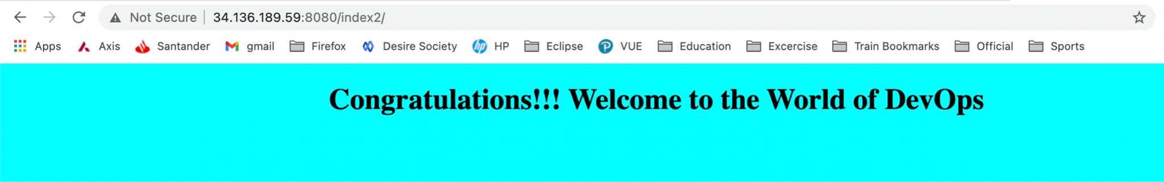
3. 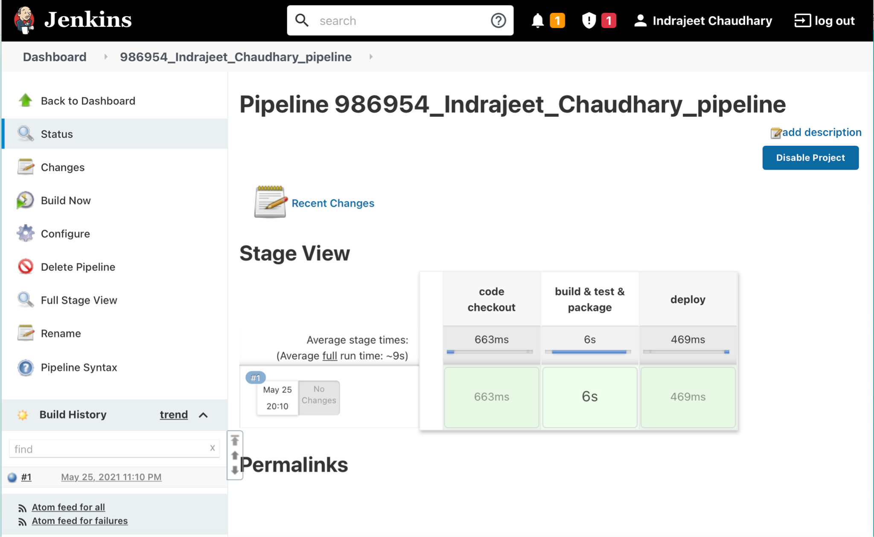

2. Created below free-style project to have web-hook trigger in place. This gets triggered as soon as a commit is done in github and builds the code in jenkins and deploys the same in tomcat. Please find below the screenshots:

1. 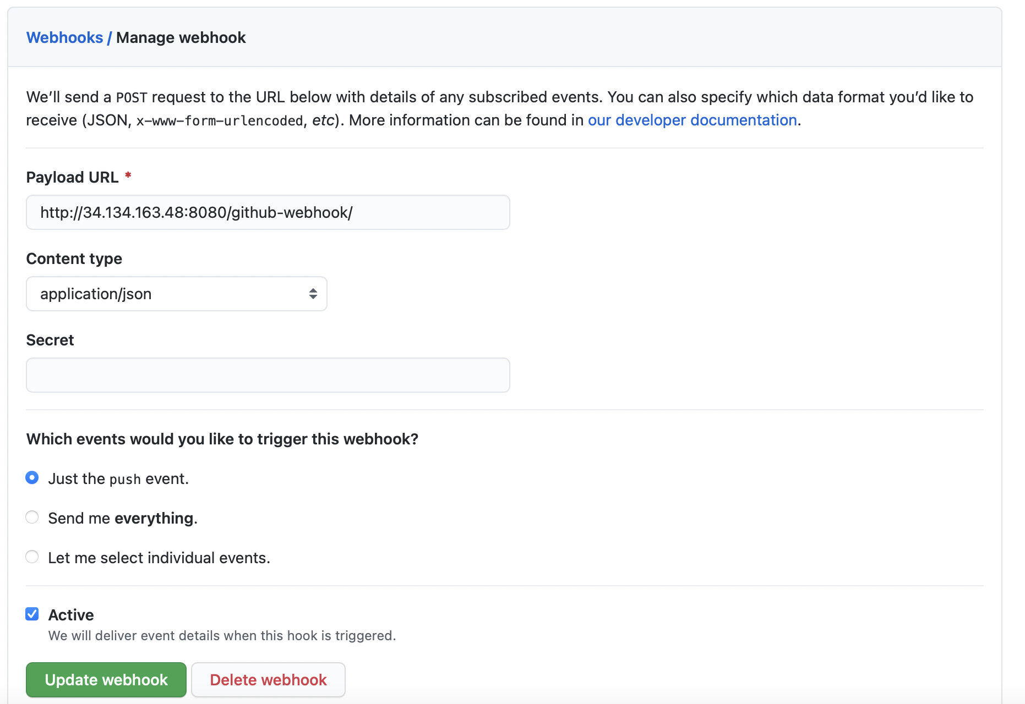
2. 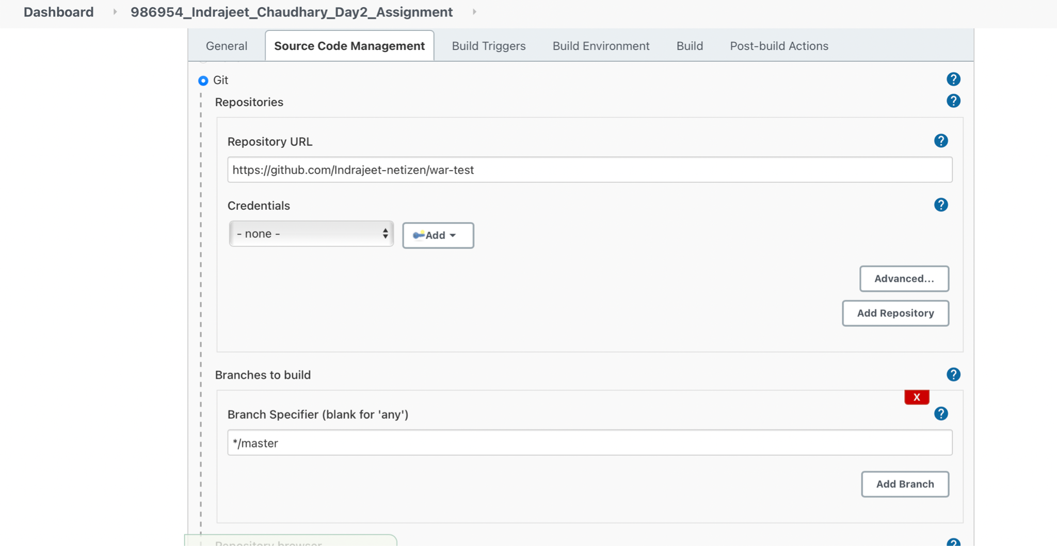
3. 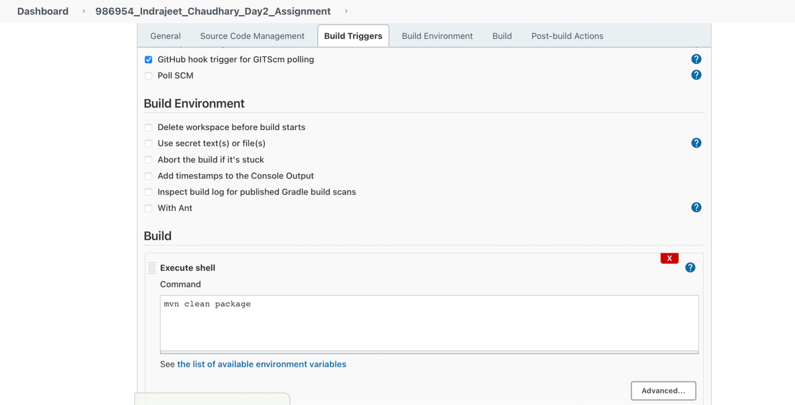
4. 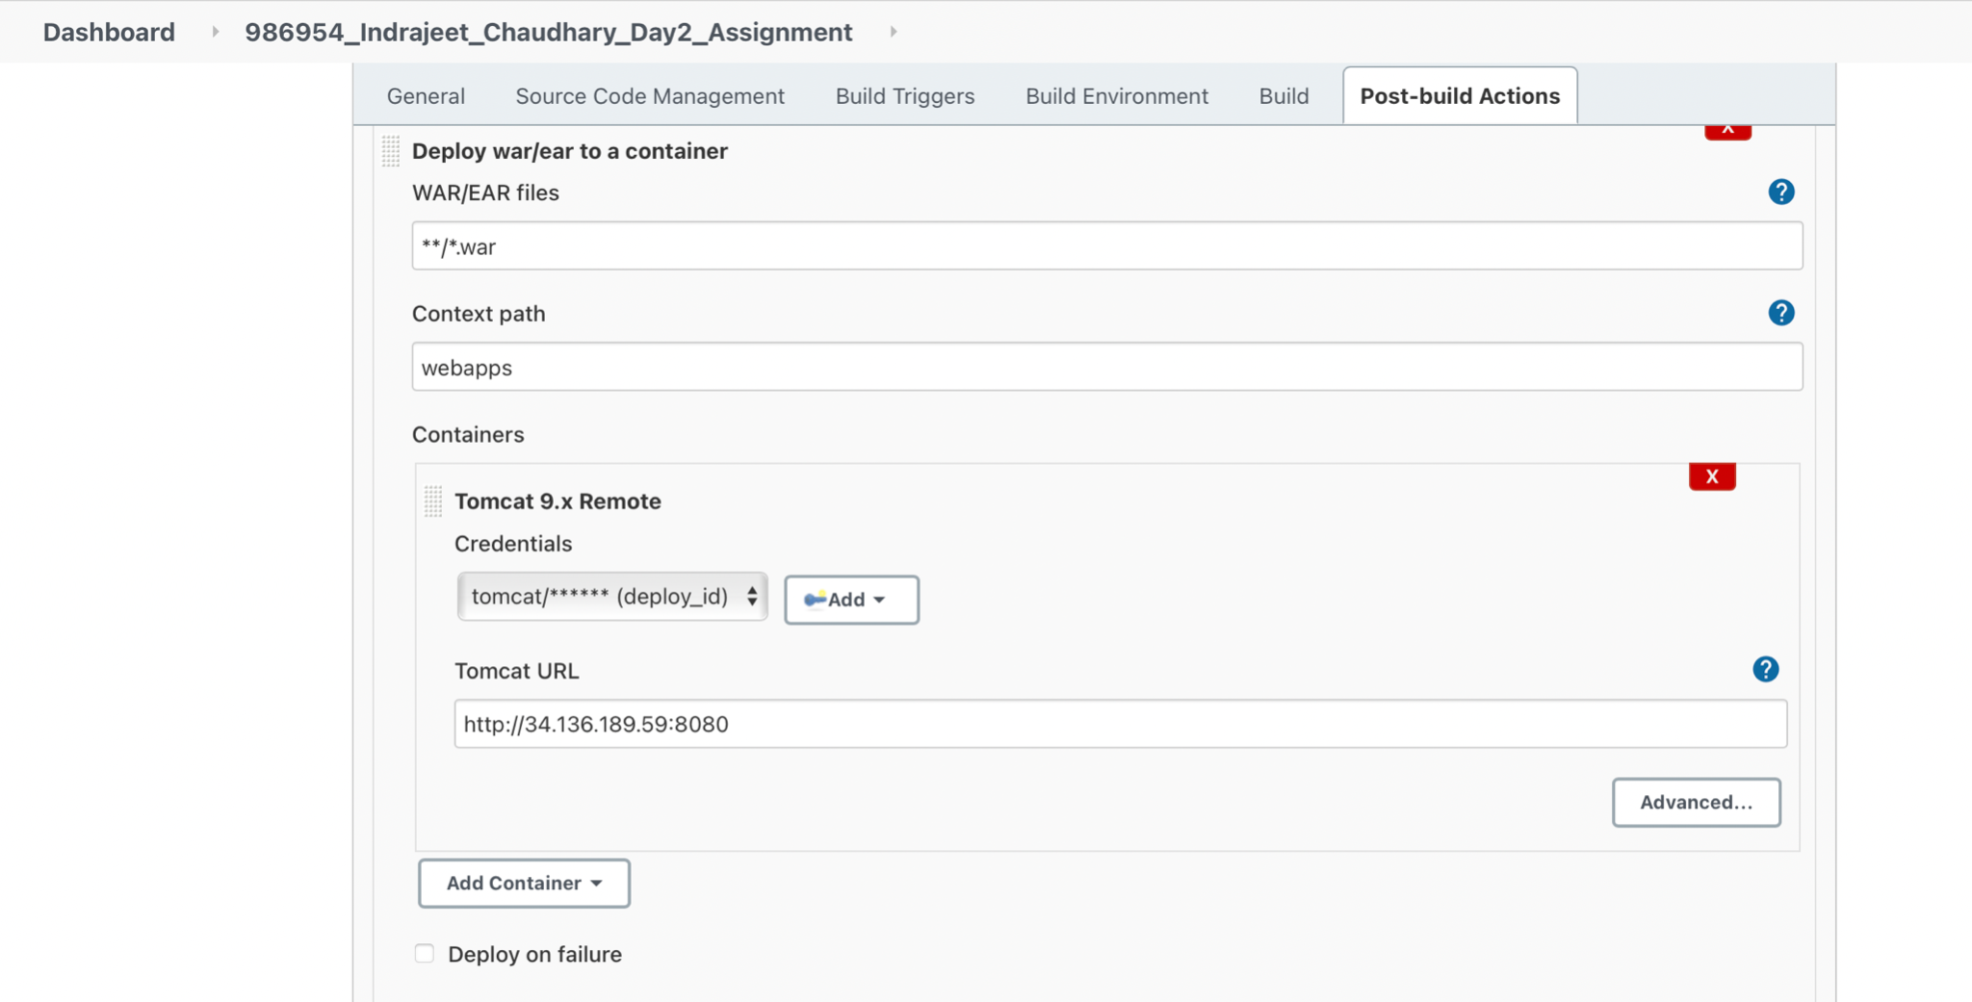
5. 